GEORGIA tax collection system
Master Manual

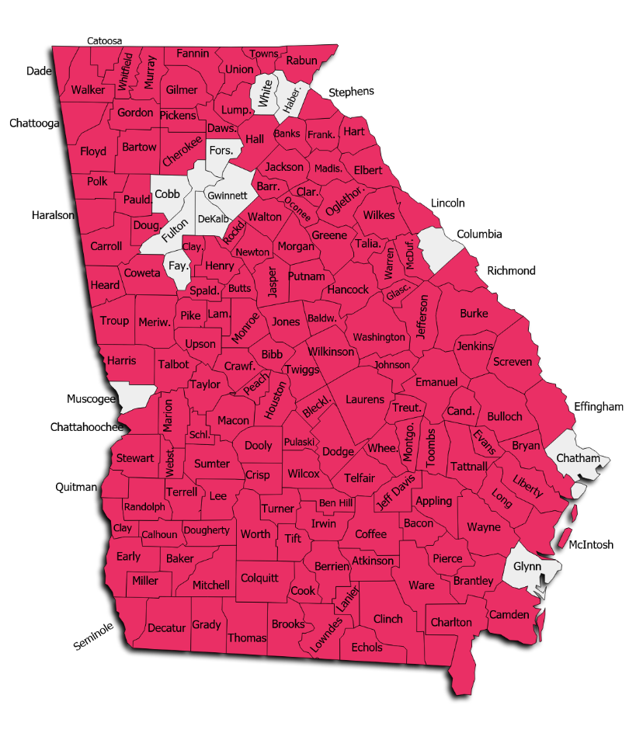
(Map is a little overboard on the number of G1 counties. We will get there someday).
Revised 2022
GATCS Version
Ignore TOC several pages. I have not learned how to make this work yet, its from Cody’s version of the V4 manual.
Table of Conten
Table of Contents i
Introduction 1
Interface Basics 2
File Menu 5
New Owner 5
Select Appraisal Year 6
Logon as a Different User 9
Import 10
Export 21
Launch Report Site 43
Upload Files to FTP 43
Download From FTP 44
Print Setup 44
Exit 45
SQL Menu 45
Server Mode Dialog 46
Upload DBF Data 47
Truncate Log Files 48
Launch Debug Viewer 49
Verify Data Files – FULL 50
Custom Queries 51
Foreign Key Cleanup 52
Create Triggers 52
Delete Triggers 52
Create Reappraise SP 53
Backup SQL Database 53
Check All Structures (Strucfix) 55
Property Maintenance Menu 57
Wild Search 57
Owner 60
Real 64
Personal 80
Manufactured Housing 92
Future Year 93
Appeals Menu 94
Open 95
Add Motor Vehicle 96
Edit/View Motor Vehicle 106
Status Items 107
Arrange All Windows 116
Reports Menu 117
Assessment Notice Reports 118
Real 134
Personal 160
Manufactured Housing 165
Analysis 168
Administration 183
Timber 204
Report Designer 205
Launch Report Site 206
PRC Bin – Real 208
PRC Bin – MH 213
Statistics Menu 215
Basic Selection 215
Advanced Query 224
Neighborhood Analysis 232
Tools Menu 244
Password Administration 245
Schedules/Tables 248
Residential Improvements 249
Commercial Improvements 278
Manufactured Housing Improvements 297
Accessories 315
Accessibility/Desirability 324
Conservation Use Land 326
FLPA Schedules 326
Land Characteristics 327
Land Influences 334
Rural Land 335
Subdivisions List 336
Timber Values 337
Urban Land 338
Tax Calculation Tables 340
Sale Reasons 352
Assessment Reasons 354
Override Reasons 361
Neighborhoods 362
Street Directory 364
Zip Code Directory 367
Discovery Sources 367
Permit Types 368
Business License Types 369
Custom Flags 370
Income Models 372
Income Categories 380
Depreciation 380
Residential Tables 381
Commercial Tables 382
Accessory Tables 384
Non Prebill Mobile Home Tables 386
Prebill Mobile Home Tables 388
APM Table 390
Cost Table 391
Cost Index Table 392
IRS Class 394
File Maintenance 395
Data Edits 395
Growth Calculations - Normal 408
Growth Calculations and LOCK 409
UNLOCK Growth Calculations 409
User Log 409
Edit Log 410
Photo Audit 412
Year End Cleanup 414
Future Folder Tasks 419
Broadcast Shutdown Message 425
Clear Shutdown Message 426
Download ABOS 426
Download NADA 428
Configure Global Push 431
Configure Appeals Push 434
Configure Push Tech Exclusions 437
Bulk Owner Address Changer 440
Bulk Parcel/Subdivision Creator 444
Recall Deleted Property 450
SQL Database Utility 452
FTP Utility 453
Re-Appraise 454
Real Property 454
Personal Property 463
Prebill Manufactured Housing 465
Boats - ABOS 467
Mfg Housing - NADA 469
Preferences 472
Change Background Color 483
Register COM Assemblies (Requires Admin) 487
Add-Ons Menu 488
PT61 Download 488
PT61 Match 497
PT61 Field Match 500
Master Address Database 517
Permit Staging 517
Timber 517
Help Menu 526
Contents 527
WinGAP on the web 528
WinGAP Version Changes 529
Contact Tech Support 530
Online Support 531
About This Application 535
Owner Search Form 537
Multiple Owner Search Form 550
Real Index Search Form 557
Real Property Search Form 561
Personal Property Search Form 578
Prebilled Manufactured Housing Search Form 596
Property Transfer Form 615
Owner Information Form 627
Real Property General Information Form 638
Land Information Form 710
Covenant Information Form 724
Residential Improvements Form 756
Residential Improvements Calculation Summary Form 769
Non-Prebilled Mobile Homes Form 778
NADA 789
Add-Ons 793
Transfer to Prebill 797
Deleting a Non-PreBilled Mobile Home 799
Sketching Module 800
Commercial Improvements Form 835
Commercial Improvements Calculation Summary Form 850
Accessories Form 852
Sales Information Form 856
Building Permits Form 865
Appeals Form 868
Duplicate Items Form 876
Business License Form 879
Income Form 882
ACO Form 892
Estimated Taxes Form 895
Prebilled Mobile Homes Form 899
NADA 916
Add-Ons 920
Transfer to Homestead 924
Appendix 926

Introduction

The Georgia Tax Collection System (hereafter in this manual referred to as G1) is a program used in Tax Commissioner Offices in the State of Georgia for the billing and collection of property taxes. It is currently in use in 4 counties, and more are expected to use it in the coming months and years. K&G Consulting LLC is the owner of GA1 software. K&G is a Georgia based company that specializes in providing services for Tax Commissioners and Tax appraisers in the State of Georgia and other states in the Southeast.

Interface Basics

Logging in to G1

When G1 is first initialized, the user must log in with a User ID and Password that is managed by the administrator in the Tax Commissioner’s (hereafter in this manual referred to as TC) office. The Guest option can be used by a computer used by the public, which does not require any ID or Password. Logging in as a User will allow all the rights associated with that User ID including all granted viewing and editing rights, while the Guest logon has restricted viewing rights and no editing rights.

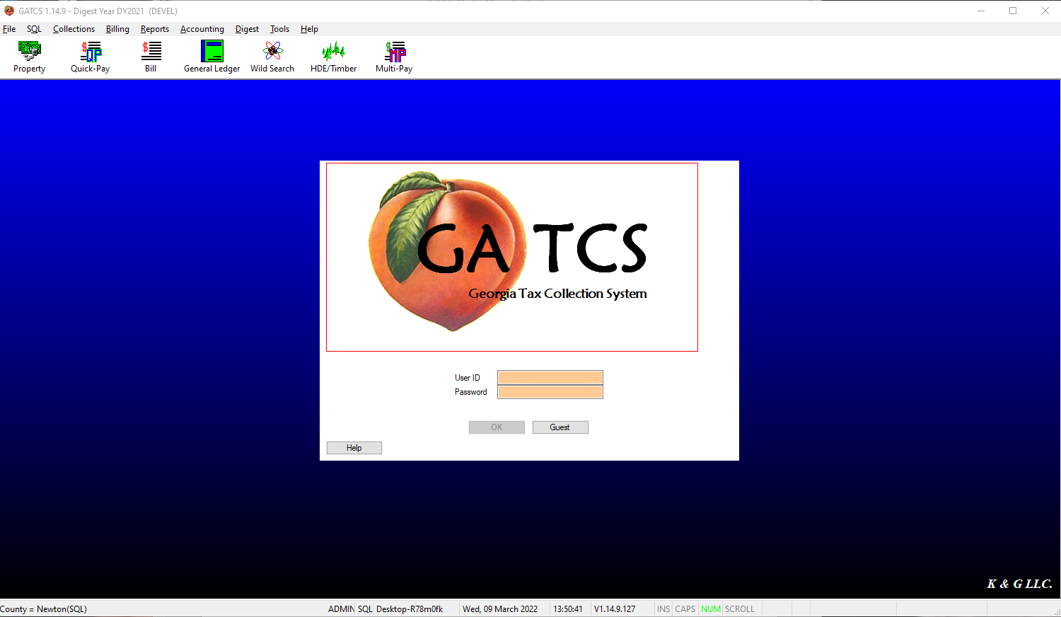

Main G1 Screen

After logging in, the user is taken to the Main Screen. All G1 operations originate at this screen, which defaults to a graduated blue color (which can be changed) and is similar to the primary screen in most Windows applications.

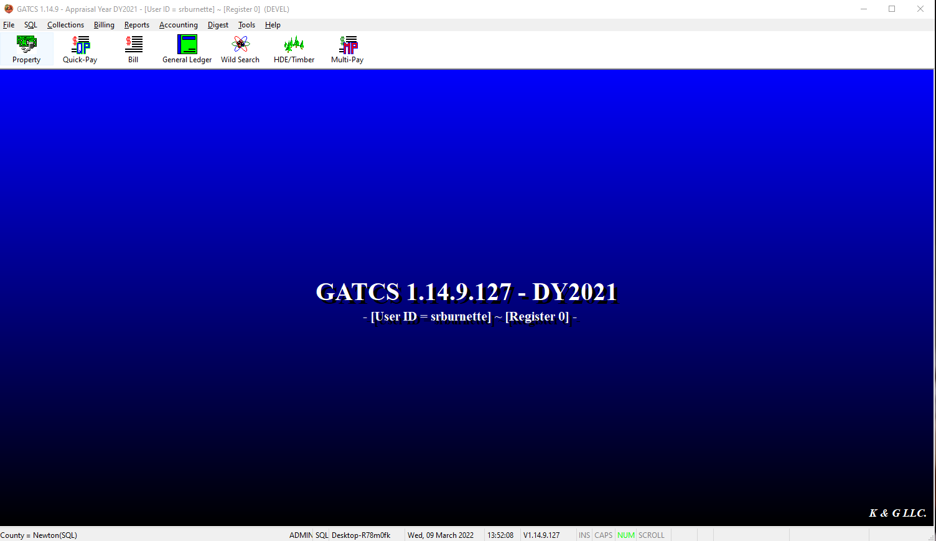
Main Window
Tool Bar
Menu Bar
Title Bar

Main Window
The main G1 screen is a blue color when the user is in the default digest year. The screen is a red color when the user is in a previous digest year or logged in as Guest. The version of G1 will display in the center of the window, as seen below, along with the digest year in use. If Logins are enabled, the Login ID of the user will display below the WinGAP version. The Register Number assigned to this user, needed for audit trail and user accountability, displays to the right of the User ID.



Title Bar
The Title Bar at the top of the screen contains the Name of the program (GATCS), the Version Number of G1 (in this case, 1.14.9), the Appraisal Database that is currently being used, and the login id of the user. On the far left of the Title Bar is an icon that can be clicked to produce a Menu where the user can resize the main WinGAP screen or close the G1 application. On the far right of the Title Bar are the standard Windows buttons that can be used to Minimize, Maximize/Restore, and Close the Main G1 screen.

Menu Bar
The Menu Bar contains pull-down menu options that allow the user to perform different functions within G1. These menus can be selected by either clicking on the menu word with the mouse (for instance by clicking the word "File"), or they can be selected with what is known as a “hot-key” combination. Hot key combinations are performed by holding down the Alt key and pressing the underlined letter for the menu item you want (for instance pressing ALT + F will pull down the File Menu).

After a menu is activated, the user has several methods available in selecting the desired menu option. These methods are listed below and apply to all menus.

- Pointing at the desired menu option with the mouse and single clicking the left mouse button.
- Using the Up and Down directional arrow keys on the keyboard to navigate through the menu option and then press Enter when the desired option is highlighted.
- Using a hotkey combination. Menu options that have hotkey combinations have them displayed to the right of the option. Hotkeys can initiate a menu options without first activating the menu. For example, CTRL + N would display the Owner screen without the File menu being displayed or dropped down.

Each of these Menus will be discussed in more detail on the following pages.

Tool Bar
The WinGAP Tool Bar contains Buttons that can be clicked on to perform various tasks in G1. Many of these Forms can also be reached with the use of a “hot-key” combination. From left to right, clicking on the Buttons will produce the following items:
NOTE: Not updated yet.
- Property Search Form (CTRL + O)
- Multi-Owner Search Form (CTRL + M)
- Real Property Index Form (CTRL + V)
- Real Property Search Form (CTRL + R)
- Personal Property Search Form (CTRL + SHIFT + P)
- Prebill Mobile Home Search Form
- Property Transfer Form (CTRL + T)
- Timber Form
- Report Designer
- Wild Search
- Report Site

